# Tutorial 8B

Text Mining, Network Mining, Matrix, SQL, NumPy, & Pandas Read/Write CSV

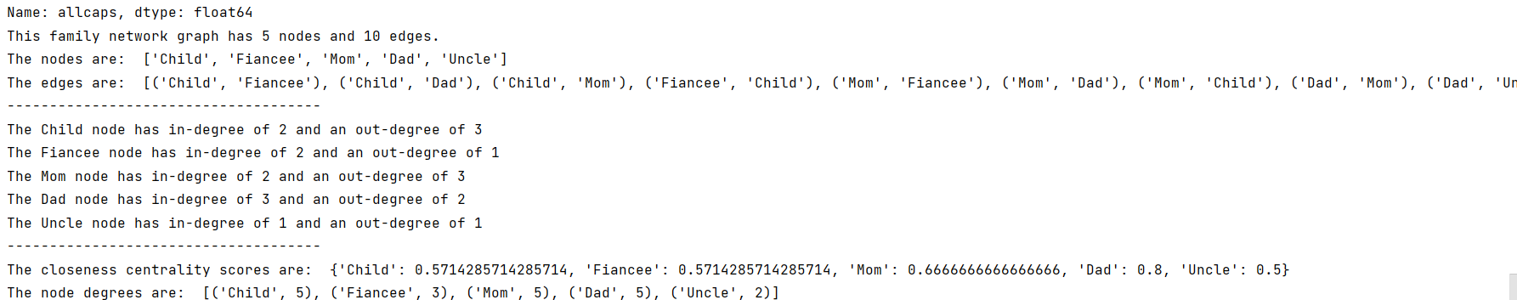

Complete ss🡪

